12.SINIF
Tema | Kazanımlar | Soru sayısı
5 PSYCHOLOGY | E12.5R1. Students will be able to read a poem loudly by reflecting its tone. | 1
5 PSYCHOLOGY | E12.5.R2. Students will be able to identify specific information in a real-life text. | 1
6 FAVORS | E12.6.R1. Students will be able to scan a text for the specific information about a charity organization/foundation. | 1
6 FAVORS | E12.6.W1. Students will be able to write an announcement to invite people for a charity organization. | 1
7 NEWS STORIES | E12.7.W1. Students will be able to paraphrase news/ stories/ past events. | 1
8 ALTERNATIVE ENERGY | E12.8.R2. Students will be able to analyze a reading passage to find out solutions to environmental problems. | 1
5 PSYCHOLOGY | E12.5.L1. Students will be able to list the suggestions to change mood given by a psychologist/friend in recorded text. | Uygulama sınavı
5 PSYCHOLOGY | E12.5.L2. Students will be able to identify the speaker’s mood, tone, etc in a recorded text. | Uygulama sınavı
5 PSYCHOLOGY | E12.5.S1. Students will be able to make a Roleplay between a psychologist/school counsellor and a client. | Uygulama sınavı
5 PSYCHOLOGY | E12.5.S2. Students will be able to make comment on moods by looking at flashcards. | Uygulama sınavı
6 FAVORS | E12.6.L2. Students will be able to complete a conversation about favors in a recorded text/video. | Uygulama sınavı
6 FAVORS | E12.6.S2. Students will be able to act out a self-prepared dialogue about requests/favours. | Uygulama sınavı
7 NEWS STORIES | E12.7.L1. Students will be able to list the sequences of the past events in a recorded text/video. | Uygulama sınavı
7 NEWS STORIES | E12.7.S1. Students will be able to narrate the events in the past. | Uygulama sınavı
8 ALTERNATIVE ENERGY | E12.8.S1. Students will be able to make complaints and offer solutions to environmental /energy problems. | Uygulama sınavı

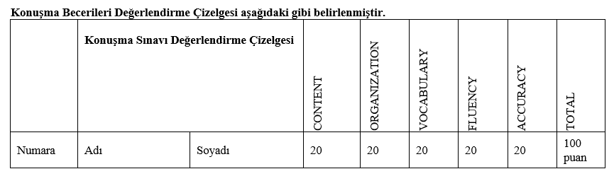
Öğrencinin sınav notu şu hesaplama ile belirlenir:
Yazılı sınav notunun % 50’si (+) Dinleme uygulama sınavının %25’i (+) Konuşma uygulama sınavının %25’i

